###### 745ecf_3c8a5c89d7c943348479abdd0e8e6d4a

###### Youth Development Council of Greene

###### CONNECTING CHILDREN, CONNECTING FAMILIES, CONNECTING COMMUNITY

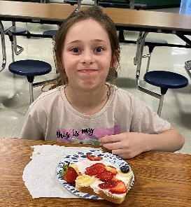The Youth Development Council of Greene serves 48 students in grades 3rd to 8th. “YDC” provides after-school programming as well as four weeks of summer camp. The after-school programs are held four days a week at Nathanael Greene Elementary and William Monroe Middle schools from 3 p.m. to 5:30 p.m. Ruckersville Elementary students are transported to NGES for after-school programs. YDC pays for transportation.

A typical day for the after-school program:

* Students are checked in and served a healthy snack/meal.
* Students have 25-minute period of outdoor games and free time.
* Students have a 30-minute period to work on reading and math skills and make up class work.
* Students have a 15-minute period focusing on character development/emotional regulation.
* Students have a 45-minute activity period. There are various activities including Art, STEM, Cooking, Guest Speakers from different organizations and more.

\*Students receive plenty of attention with a student to staff/volunteer ratio of 3 to 1 or lower.

Elementary and Middle school students enjoy two weeks of summer camps… two weeks for elementary and two weeks for middle. The camps are located at Dover-Foxcroft farm and various churches from 9 a.m. to 1 p.m.

Students are served breakfast as well as lunch. Students like to call them “Lunch Dinners” since they are usually dinner like meals with extra servings. YDC covers the cost of transportation where and when needed. Students enjoy a variety of activities including swimming, fishing, water games, sports day, arts/crafts, cooking, bee keeping, line dancing, field trips, character development, reading and story time, lip sync, and a lot more.

YDC feels that It is Important to connect students to activities they like that take place inside or outside the school. We help families and students connect with parks and recreation, 4-H, and more and help cover fees. Also, we help families in need connect with local support resources like Feeding Greene, Grace Alliance, Greene Care Clinic, Region Ten and Churches.

YDC is celebrating its eleventh year. It is program that truly cares for students and families… building relationships is key. YDC is **“FREE”** for our students and families. YDC raises money through grants, local businesses, churches, and individuals. www.greeneyouth.org